**Lab 4 Group 12 Session 205 Report**

**Part 1**: LogicalStep_Lab4_top.vhd File

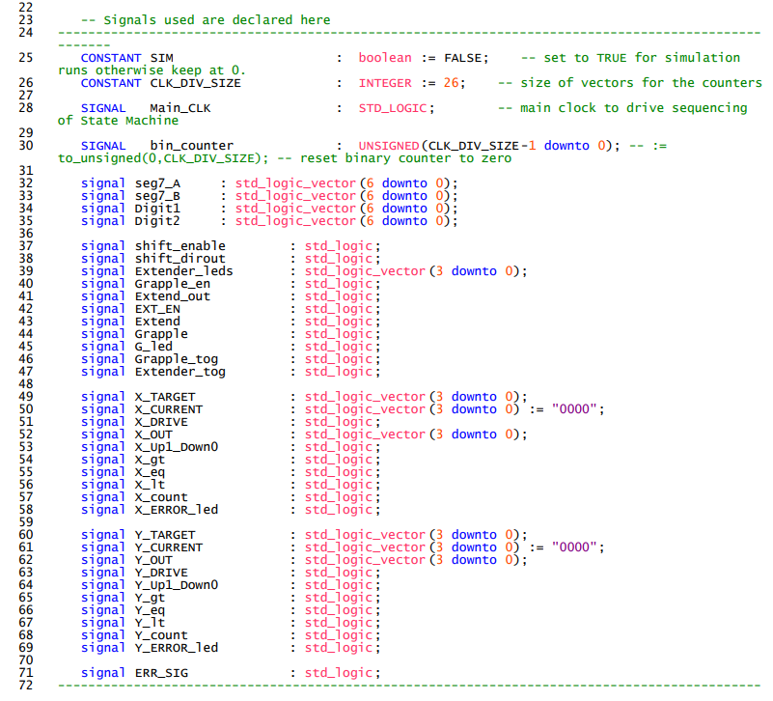

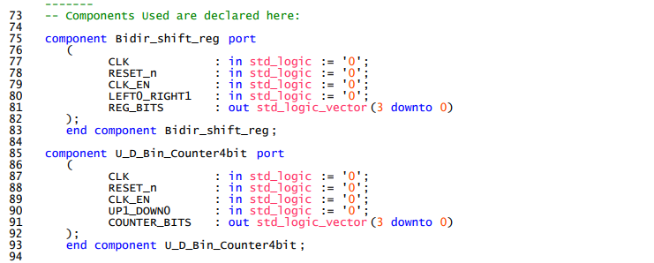

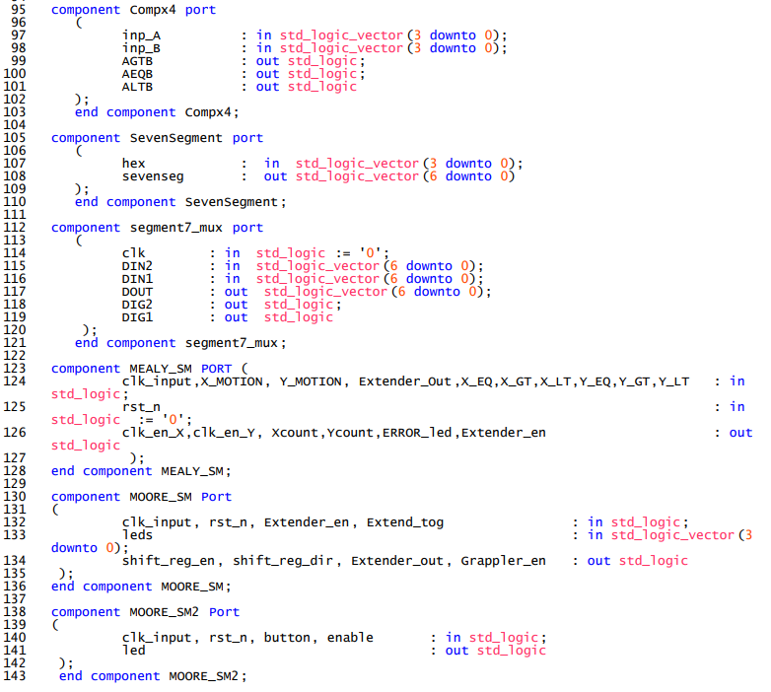

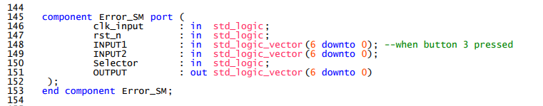

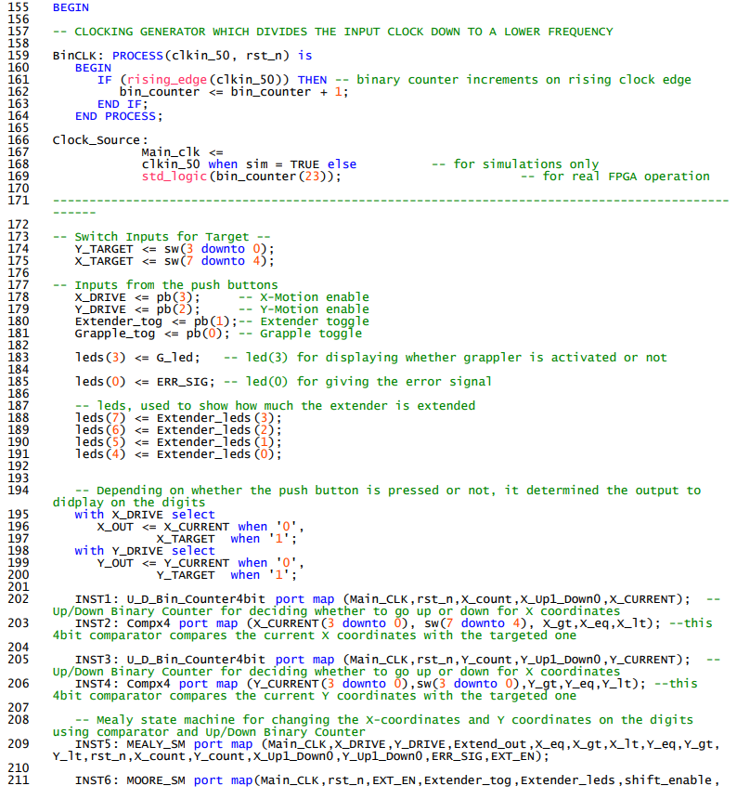

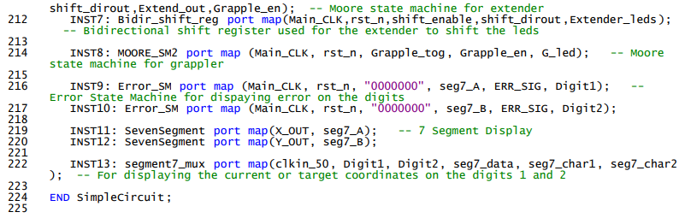

**Part 2**: Simulations of 8bit Shift Register and 8bit Binary Counter

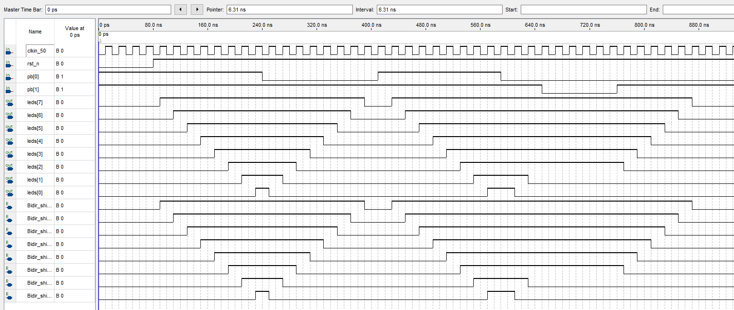

Figure1: Simulation of 8bit Shift Register

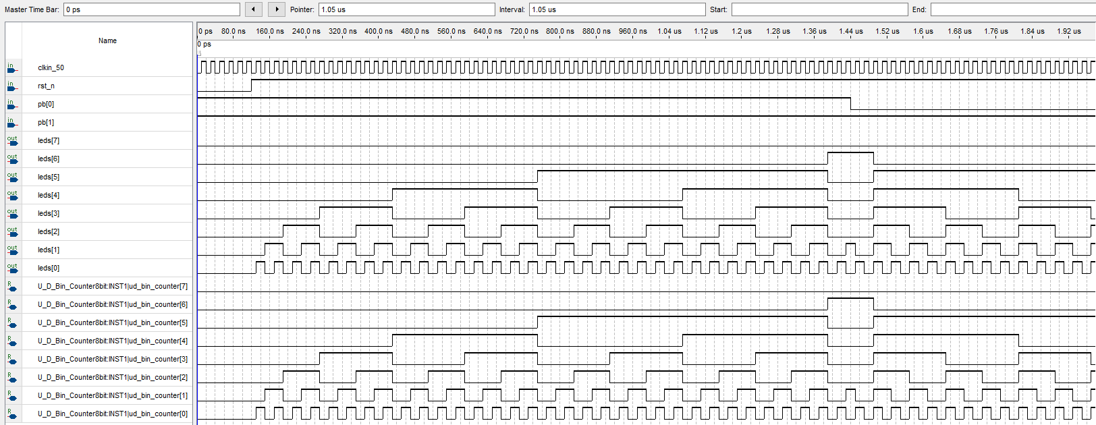

Figure1: Simulation of 8bit Binary Counter

**Part 3:** State Diagrams of Mealy State Machine and Moore State Machine 1

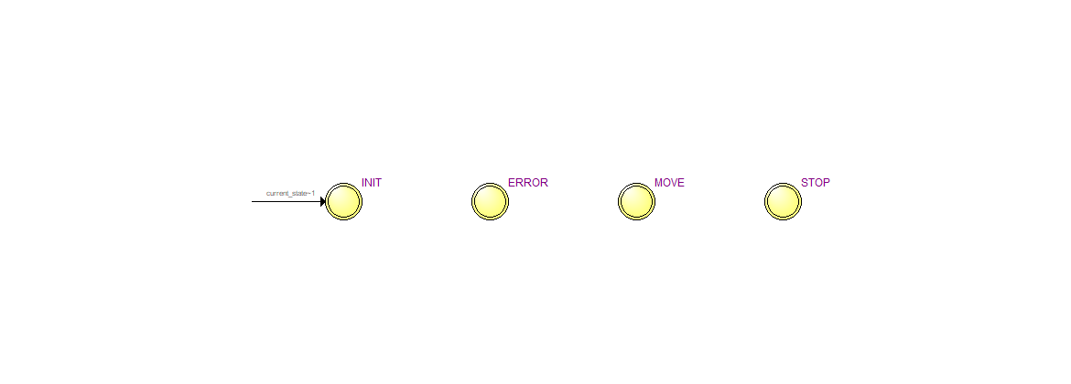

Figure1: State Diagram of Mealy State Machine

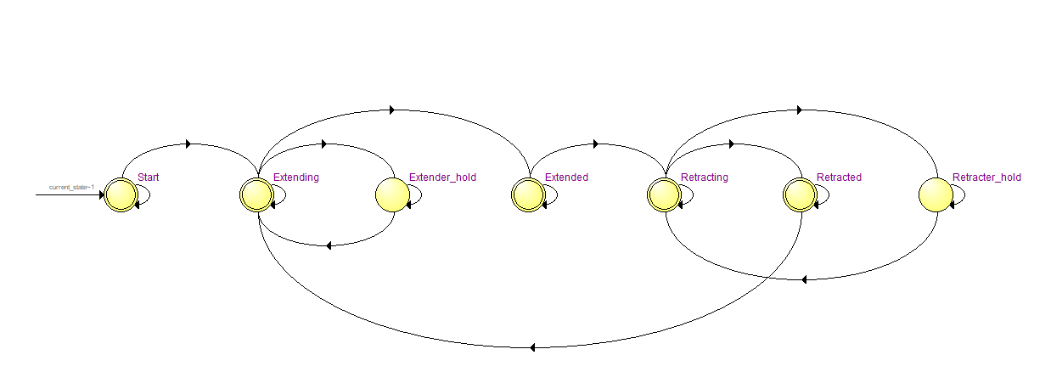

Figure2: State Diagram of Moore SM1

**Part 4:** Mealy form Mealy SM and Moore form of Moore SM1

1. Mealy SM:

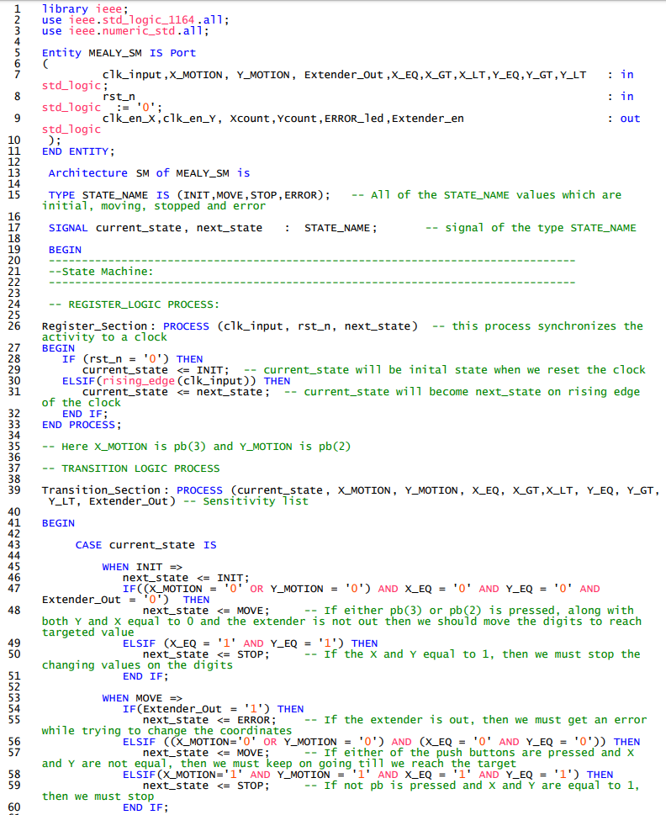



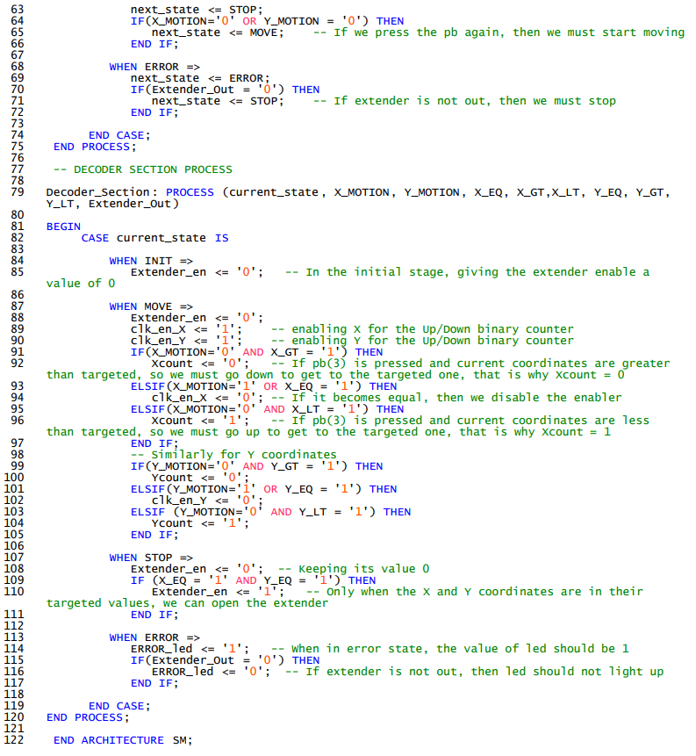

1. Moore SM1:

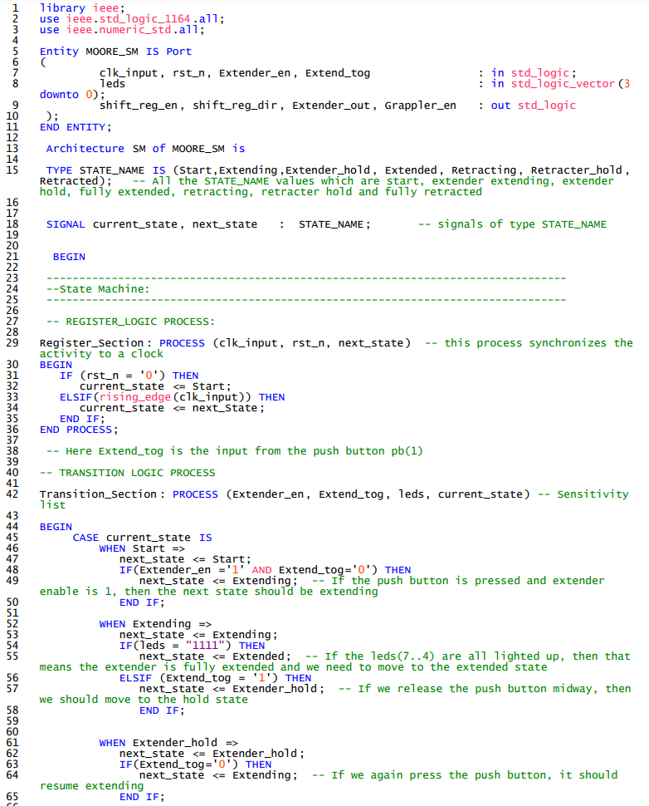



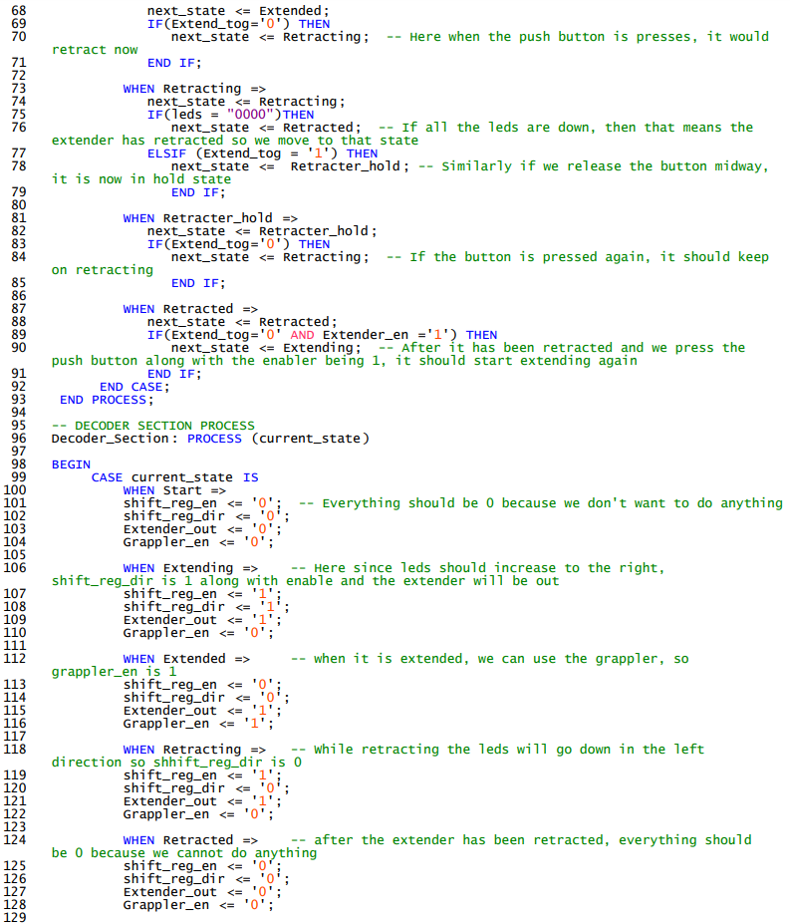

 

**Part 5:** Fitter Report on Resource Utilization by Entity

